
URL: https://lashesbyaree.com/

Primary Keyword | Secondary Keywords
Best Eyelash Extensions In Houston Tx | Eyelash Extensions  eyelash extensions near me  best eyelash extensions near me  natural eyelash extensions  eyelash extensions before and after

Add focus keywords in our content at least 7 times and we need to adjust keywords also in headings. Yet there is no keyword in our heading tags like h2 and h3.
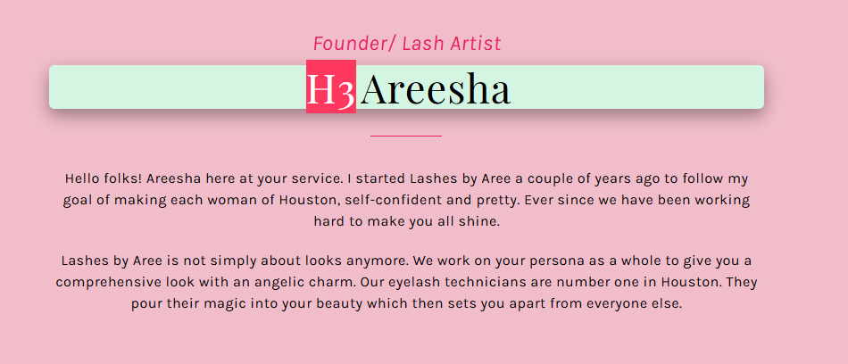
Adjust our focus keyword in h2 with proper title sense. And also put in content which is mentioned below the heading.

Meet Areesha

Founder/ Lash Artist of the Best Eyelash Extensions In Houston Tx (H2)
Hello folks! Areesha here at your service. I started Lashes by Aree a couple of years ago to follow my goal of making each woman of Houston self-confident and pretty. Ever since, we have been working hard to make you all shine.

Lashes by Aree is not simply about looks anymore. We work on your persona as a whole to give you a comprehensive look with an angelic charm. Our eyelash technicians are the number one in Houston. They pour their magic into your beauty, which then sets you apart from everyone else.

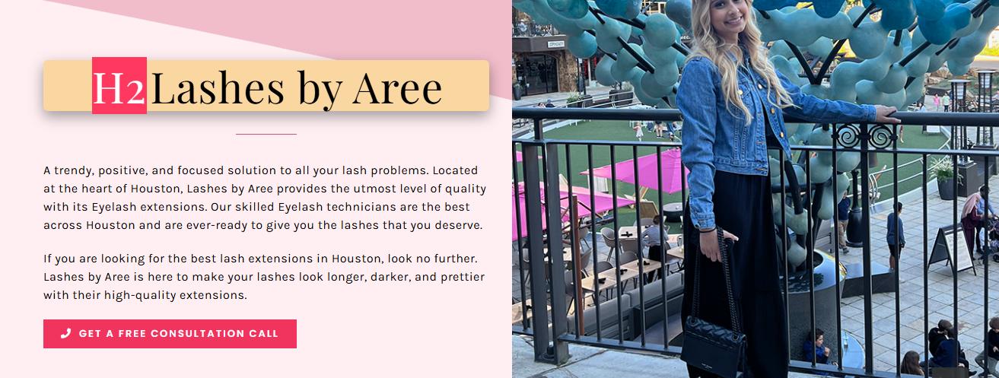
Adjust our secondary keyword in this section.

Your Go-To Spot for the Best Eyelash Extensions Near Me in Houston (H2)
A trendy, positive, and focused solution to all your lash problems. Located at the heart of Houston, Lashes by Aree provides the best eyelash extensions in Houston Tx of the utmost level of quality. Our skilled Eyelash technicians are the best across Houston and are ever-ready to give you the lashes that you deserve.

If you are looking for the best lash extensions in Houston, look no further. Lashes by Aree is here to make your lashes look longer, darker, and prettier with their high-quality extensions.
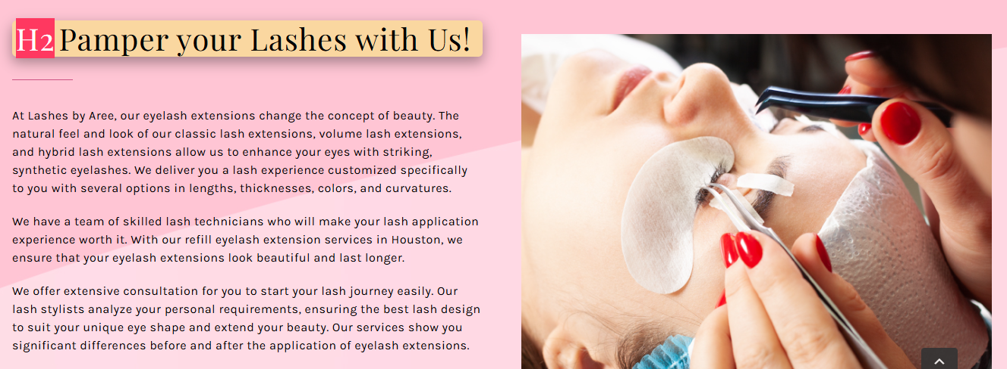
Adjust our secondary keyword in this section. With proper heading and naturally place keyword in content.

Witness the Magic of the Best Eyelash Extensions Near Me (H2)
At Lashes by Aree, our eyelash extensions change the concept of beauty. The natural feel and look of our classic lash extensions, volume lash extensions, and hybrid lash extensions allow us to enhance your eyes with striking, synthetic eyelashes. We deliver you a lash experience customized specifically to you with several options in lengths, thicknesses, colors, and curvatures.

We have a team of skilled lash technicians who will make your lash application experience worth it. With our refill eyelash extension services in Houston, we ensure that your eyelash extensions look beautiful and last longer.

We offer extensive consultation for you to start your lash journey easily. Our lash stylists analyze your personal requirements, ensuring the best lash design to suit your unique eye shape and enhance your beauty. Our services show you significant differences in eyelash extensions before and after the application of eyelash extensions.

At our place, we provide a soothing and serene environment while you’ll enjoy this beauty treatment lying back comfortably with your eyes closed, unwinding as we perform our tricks. Get your favorite eyelash extension services now from the best eyelash extensions in Houston Tx by contacting us.

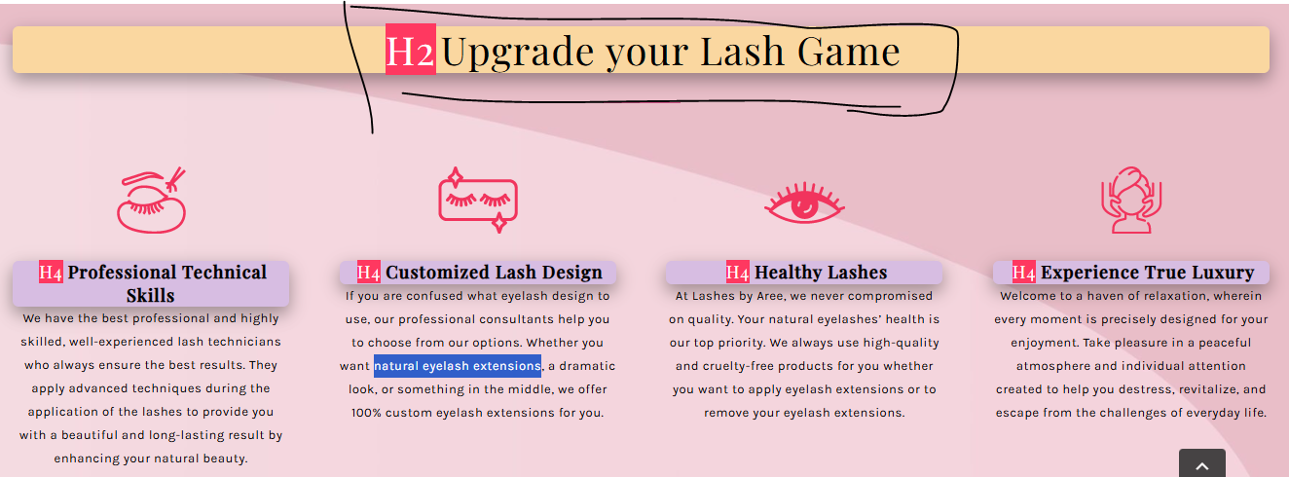
Rewrite this heading with the proper keyword.

Experience the Best Eyelash Extensions In Houston TX (H2)

Professional Technical Skills | Customized Lash Design | Healthy Lashes | Experience True Luxury
We have the best professional and highly skilled, well-experienced lash technicians who always ensure the best results. They apply advanced techniques during the application of the lashes to provide you with a beautiful and long-lasting result by enhancing your natural beauty. | If you are confused about what eyelash design to use, our professional consultants can help you choose from our options. Whether you want natural eyelash extensions, a dramatic look, or something in the middle, we offer 100% custom eyelash extensions for you. | At Lashes by Aree, we never compromise on quality. Your natural eyelashes’ health is our top priority. We always use high-quality and cruelty-free products for you, whether you want to apply eyelash extensions or remove your eyelash extensions. | Welcome to a haven of relaxation, wherein every moment is precisely designed for your enjoyment. Take pleasure in a peaceful atmosphere and individual attention created to help you destress, revitalize, and escape from the challenges of everyday life.

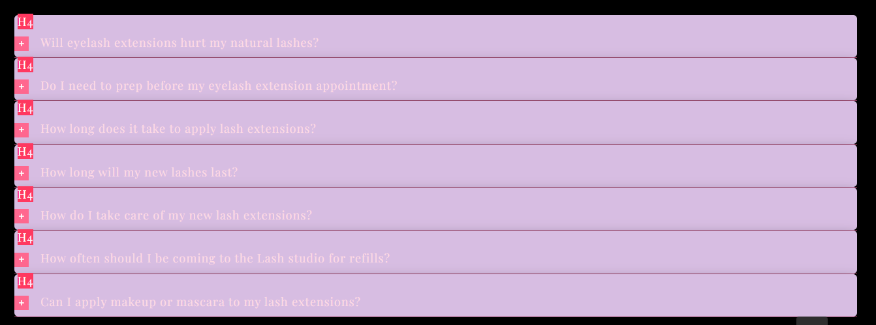
Check this faq section and place keywords naturally in heading as well as in Answers.

Note: check this document carefully and fix this content issues asap using those keywords which are mentioned above.

FAQ’s

Will eyelash extensions hurt my natural lashes? (H3)
No. The natural lashes do not fall out due to the procedure, but after their natural lifespan is over. Our skilled experts from all over Houston handle eyelash extensions with extra care so that nothing of this sort happens.

Do I need to prep before my eyelash extension appointment? (H3)
Try not to use any eye makeup for at least a day or two before your appointment. Only then will you get the best results from eyelash extensions.

How long does it take to apply lash extensions? (H3)
Most lash studios in Houston take around 1.5 hours to apply a full set of lashes. Our eyelash extensions near me salon makes the process comfortable and relaxing, so it does not feel like a lot of time when you’re in the process.

How long will my new lashes last? (H3)
A new set of lashes can last from 2 to 4 weeks, depending on your skincare routine and your own natural lash life cycle. Even the best lashes in Houston will last almost the same time, so it is recommended that you get your refills every 3 weeks.

How do I take care of my new lash extensions? (H3)
Since you’re getting the Best Eyelash Extensions In Houston TX, you don’t need to worry about this a lot. Try to keep your lashes dry for at least 24 hours after application. Avoid exposure to heat, steam, sauna, and friction, and you must be good to go.

How often should I be coming to the Lash studio for refills? (H3)
It is recommended that you get refills every 2 to 4 weeks. If you wait too long, your eyelash extensions may fall out, and you’ll need a full set. Try getting them refilled when they are 50%-60% gone.

Can I apply makeup or mascara to my lash extensions? (H3)
Yes, you can. The catch here is that you must only apply water-based mascara. The experts of our best Eyelash Extensions in Houston TX salon suggest you should avoid oil-based or waterproof mascara.

On mobile:
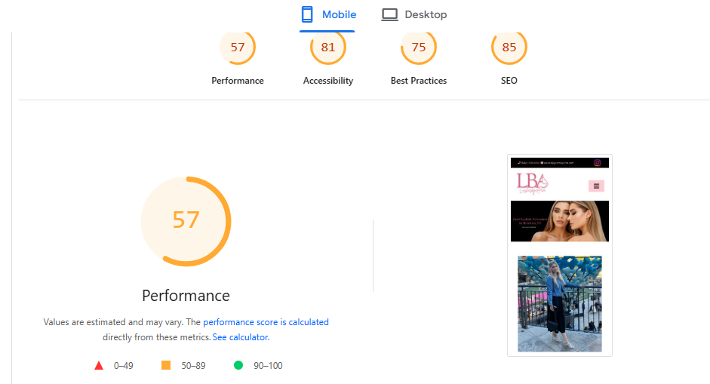

Our website's current mobile page speed score is 57. To improve it to above 90, we should focus on minifying JavaScript, CSS, and HTML files.

On desktop:

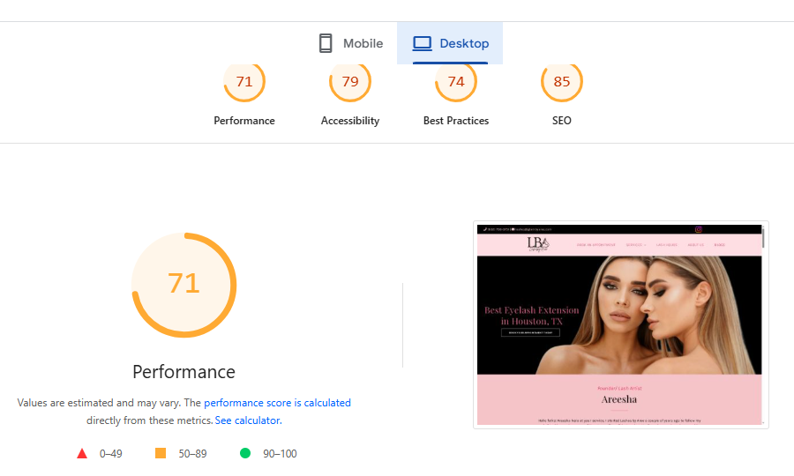
Our website's current desktop page speed score is 71. To improve it to above 90, we should focus on minifying JavaScript, CSS, and HTML files.

Swiss ice web copy needs to update on the website for watches-breitling pages sent to Abeeha C.
webcopy content for swiss ice for Franck Muller is done and sent to Abeeha C.
webcopy content for swiss ice for watches hublot. Abeeha C
need webcopy content for swiss ice check last tab requirements send to amir
Video Ads for Jewelry Promotion page keyword research is done for web4 jewelers
Carousel Ads for Jewelry Collections page keyword research is done for web4 jewelers
Slideshow Ads for Jewelry Marketing page keyword research is done for web4 jewelers
Collection Ads for Jewelry Stores page keyword research is done for web4 jewelers
Keyword sheet is updated for web4 jewelers.
Independence day keyword research is done for jewelry and watches.
Guest posting and Social bookmarking backlinks done for Maaz Jewelers.
Guest posting and Social bookmarking backlinks done for Maharaja Jewelers.

